User Permission

User permissions in an ERP (Enterprise Resource Planning) system refer to the rights and privileges granted to individual users or user groups within the ERP system. These permissions determine what actions a user can perform, what data they can access, and what functionalities they can utilize within the ERP software.

1. **Read**: Allows users to view only data within the ERP system.
2. **Insert**: Permits users to create data.
3. **Modify**: Permits users to modify, or update data.
4. **Delete**: Grants the ability to remove data from the system.
5. **Execute**: Enables users to execute specific processes or functions within the ERP system.

How to permission in ERP

* Open Microsoft Nav ERP
* Search users and click on it

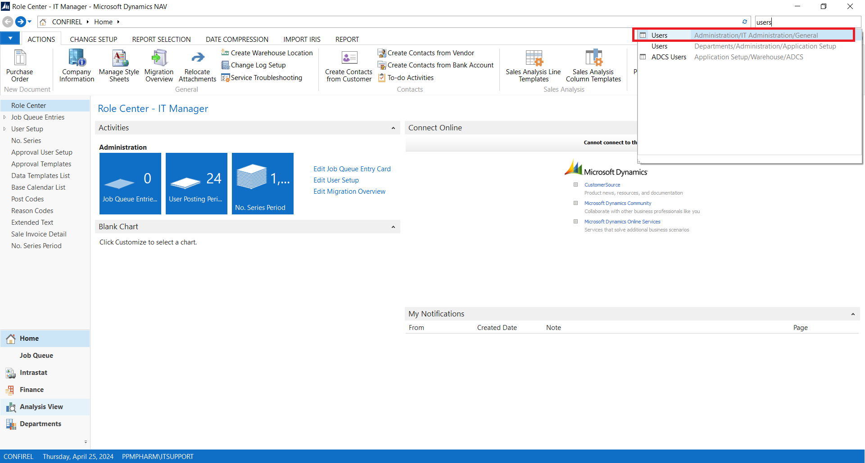

* User list will pop up select 1 among all user we want to set permission
* Click Edit

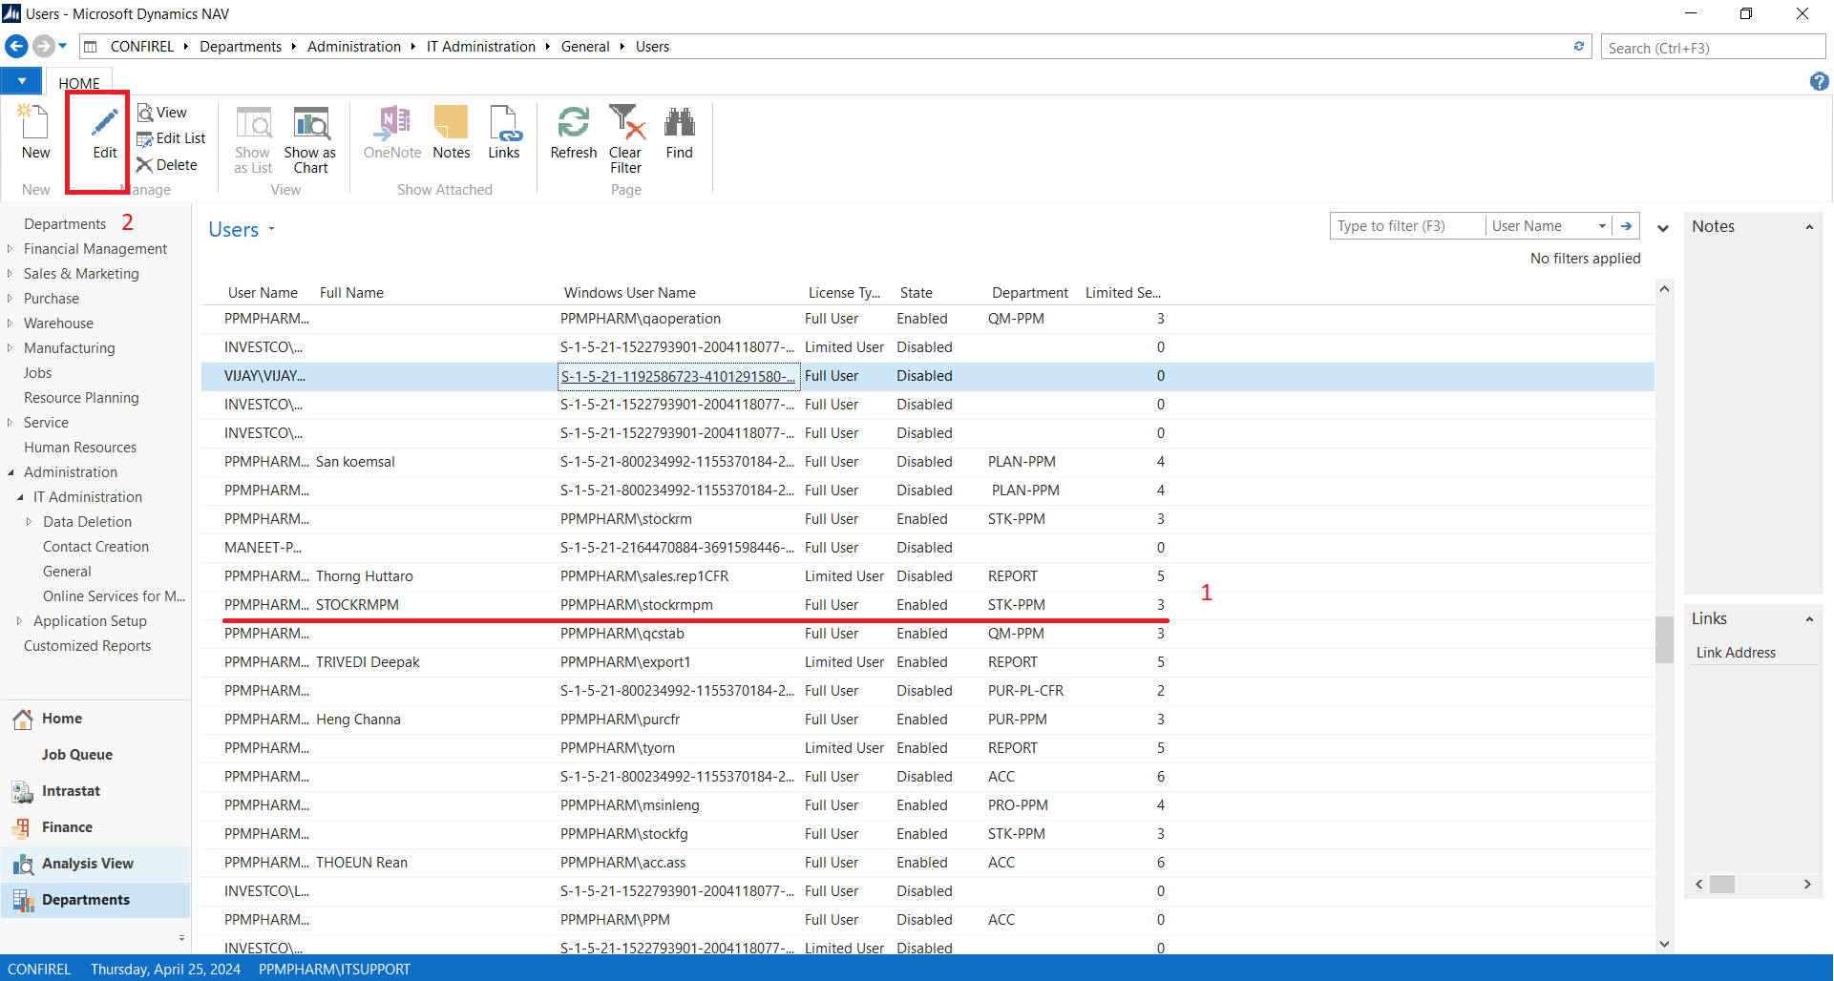

* Drop down User Permission Sets

A permission set is a collection of permissions and settings that define what a user or a group of users can do within a software application, such as an ERP system. Permission sets are used to grant additional access or capabilities to users beyond their default permissions, without modifying their user profile or role assignments.

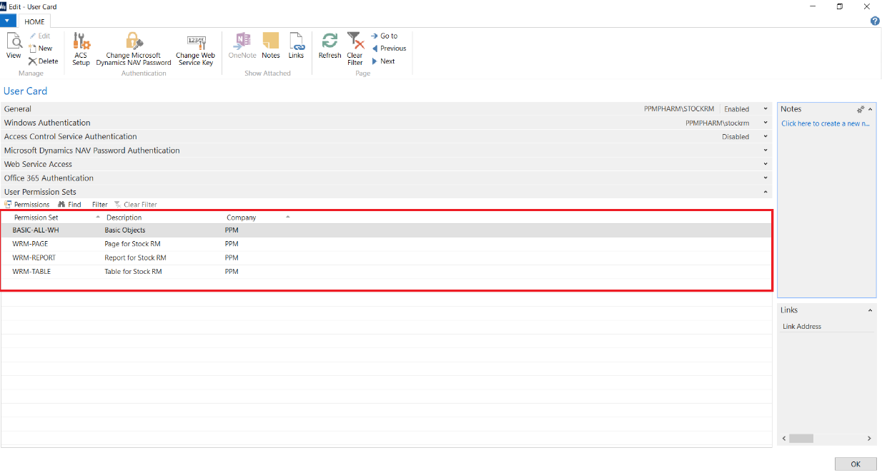

In This Example we are going to set permission this User that allow to modify unit price in Purchase Order.

* Select on 1 of permission then click Permission to view all Permission that contain in this permission set.

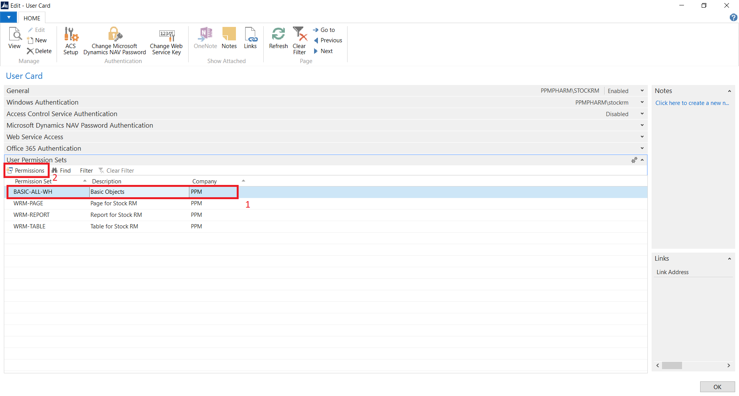

* Click All Permission and View which Permission we want to set to permission set

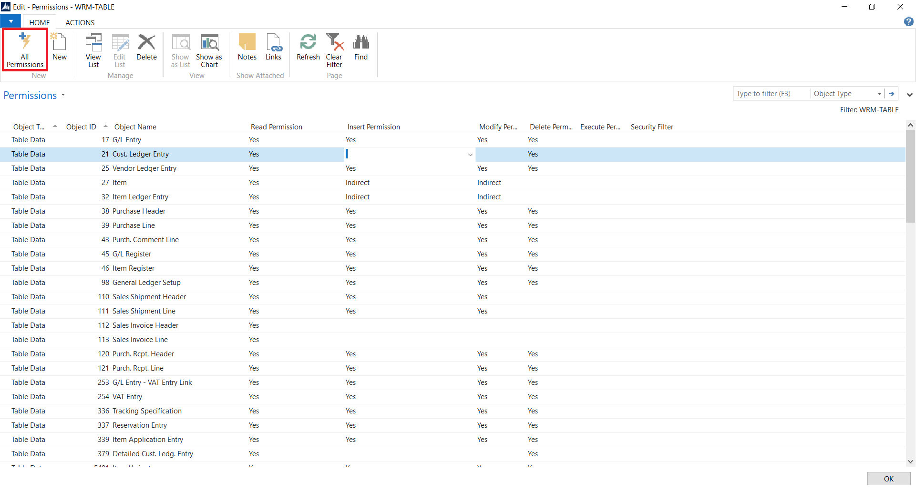

* Copy Object ID
* Click New to Create New Line
* Paste Object ID of permission to new Line

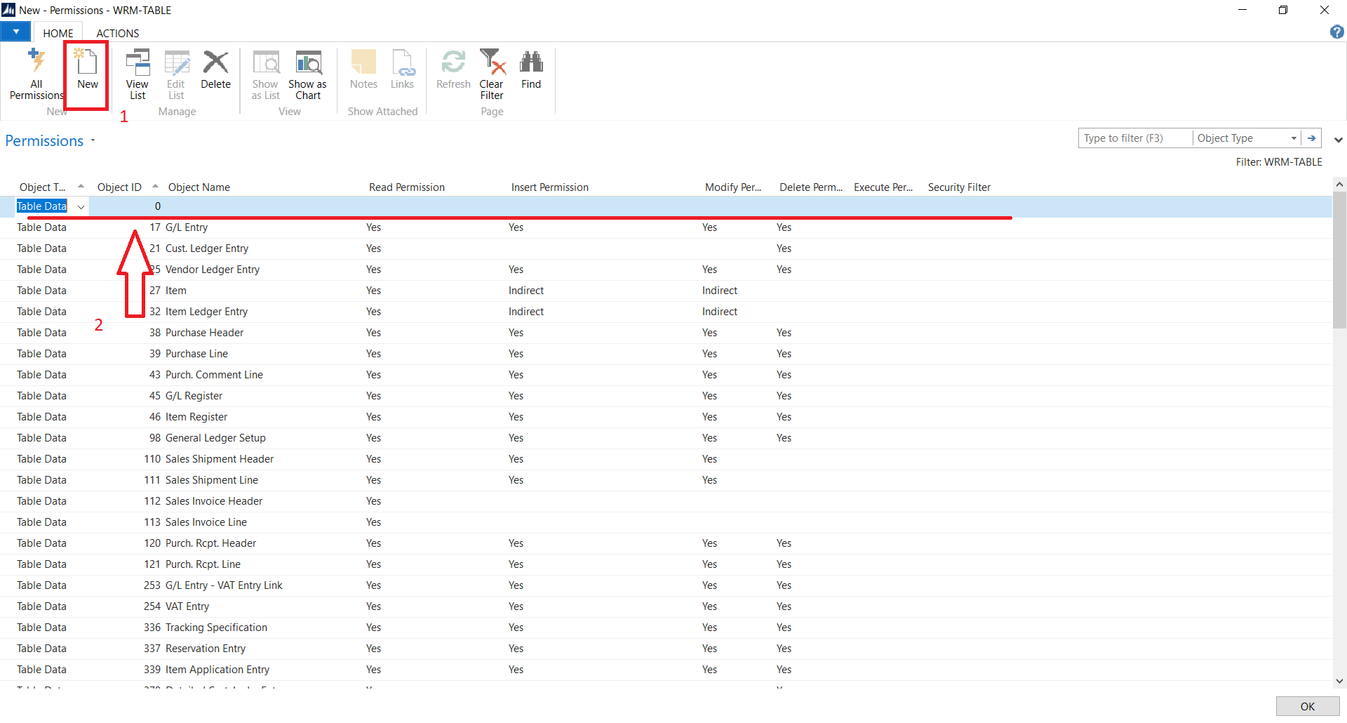

Select on Dropdown icon to see option and its show blank space that mean nothing set on the permission

Select on permission you want. And set Yes.

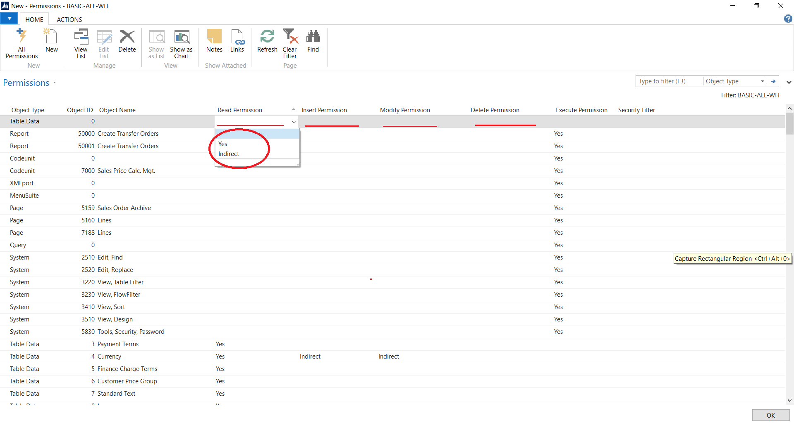

Example

User Before set permission Production BOM

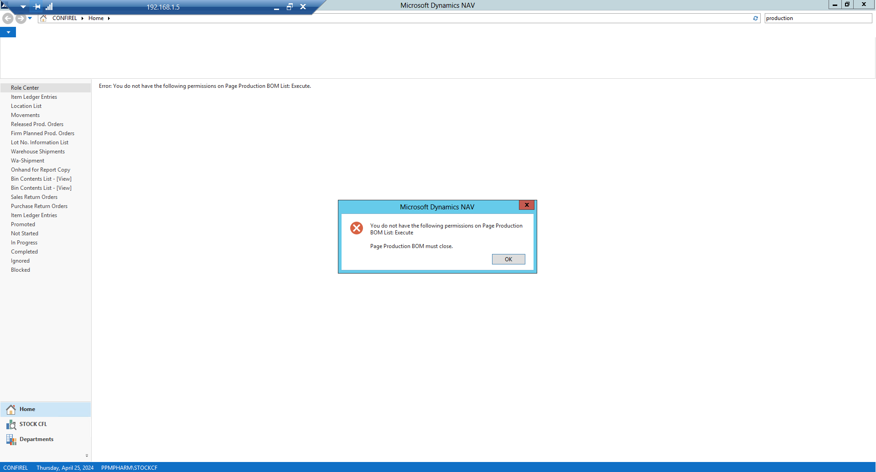

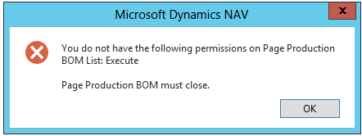

This user is not allow to open production bom

But when we set related permission

* Permission Production BOM List allow user to insert modify and delete all data in list.

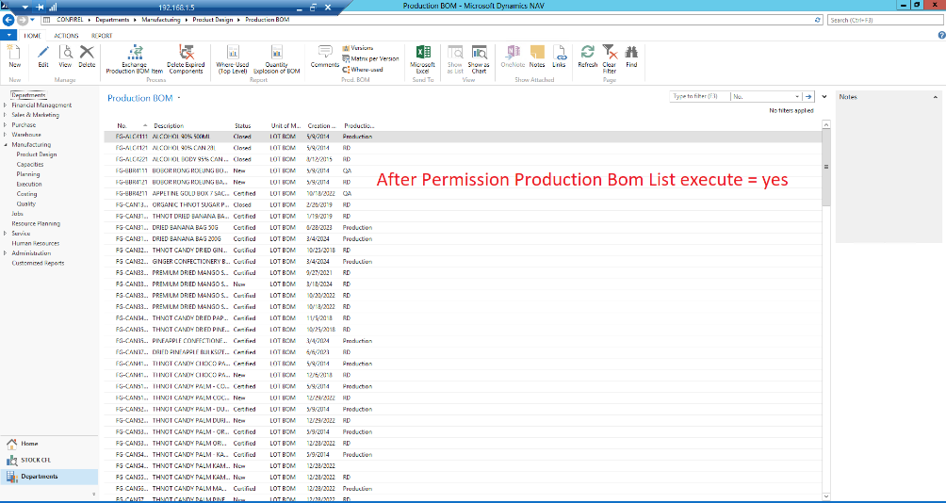

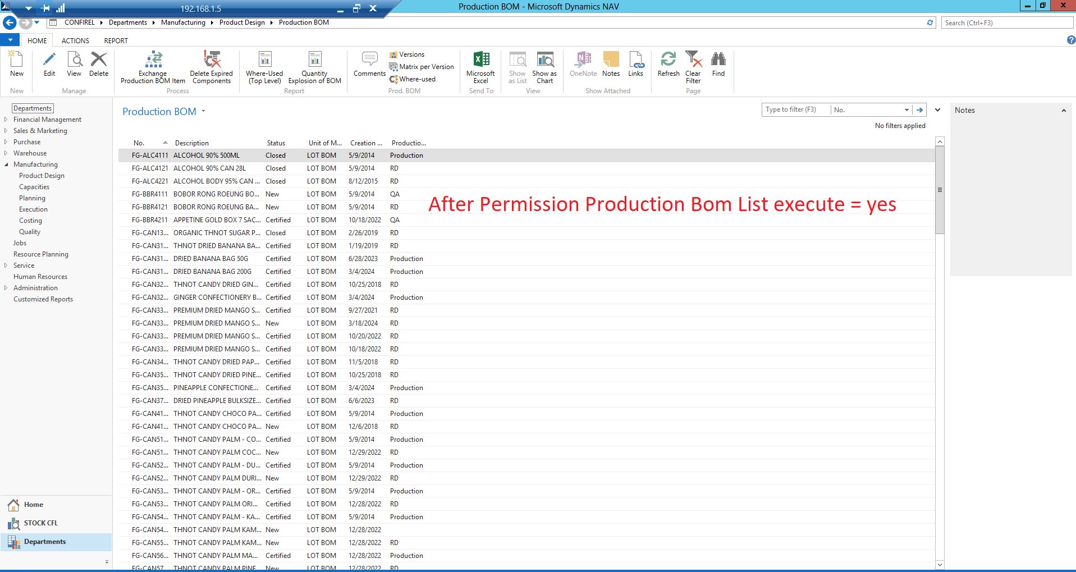

* Permission Page Production BOM Line allow user insert modify and delete only Line data.

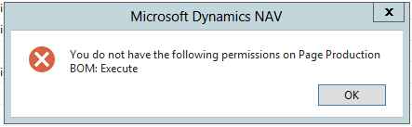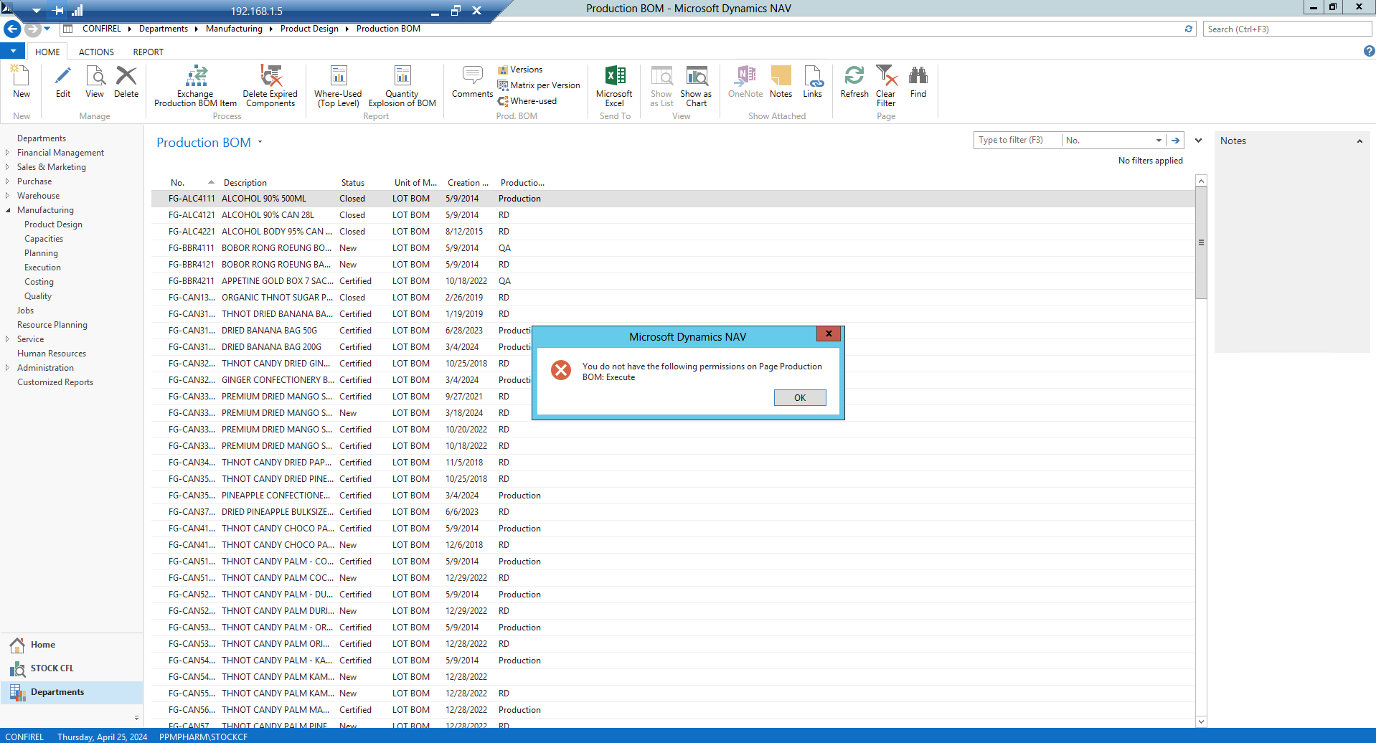

* Permission Production BOM Line allow user insert modify and delete only Line data.

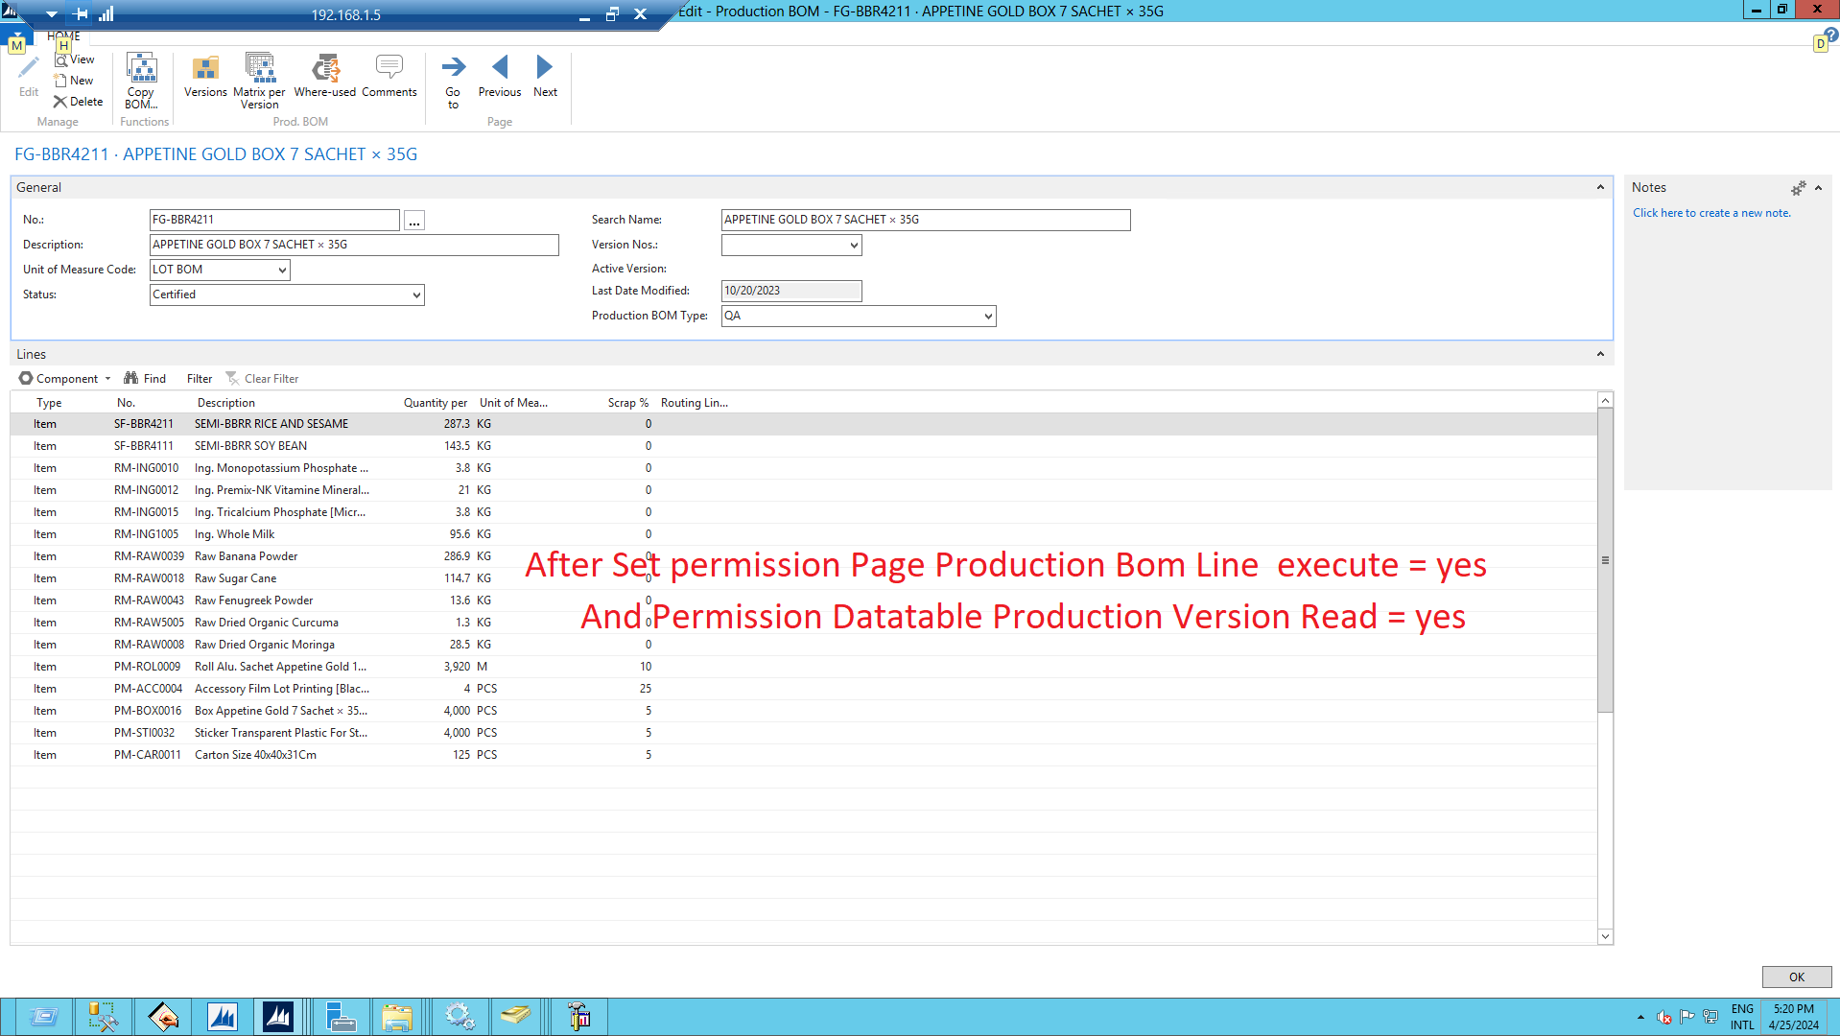

* Permission Production BOM Header allow user insert modify and delete Header.

